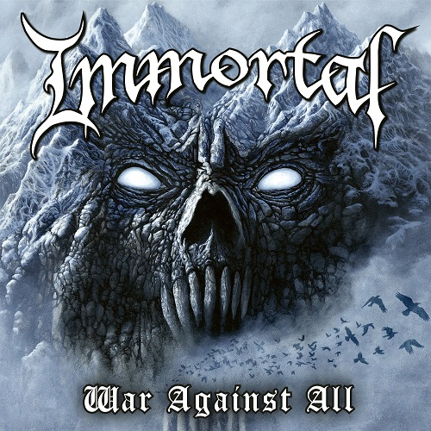

IMMORTAL
War Against All

Release Date: May, 26th 2023

Line up: | IMMORTAL online:
Demonaz | https://www.facebook.com/immortalofficial  https://www.instagram.com/immortalofficial/  https://www.immortalofficial.com/  https://www.youtube.com/immortal
IMMORTAL, from the Norwegian town Bergen, was formed by Demonaz and Abbath in 1990. The band established themselves early as one of the most important black metal bands in the world. The band released their first three albums, Diabolical Fullmoon Mysticism, Pure Holocaust and Battles In The North during the years 1992-1995. These records defined the musical style the band became infamous for.
The band then released the Blizzard Beasts album in (1997) At The Heart Of Winter (1999), Damned In Black (2000) and Sons Of Northern Darkness (2002).
In 2003 the band was put on ice, but returned to the stage in 2007 and completed several headline appearances and tours across Australia, New Zealand and the USA. All Shall Fall was released in 2009, followed by further massive festival shows and additional concerts. In 2018, IMMORTAL returned with Demonaz performing on guitar once again, also fronting the band as vocalist, releasing their 9th studio album, Northern Chaos Gods, which was very well received by both fans and global press.
Come 2023, IMMORTAL sees Demonaz releasing War Against All, the band´s 10th studio album. The record has been composed and performed by Demonaz, featuring some session members, like in earlier recordings. The album was produced by Arve Isdal, and recorded at Conclave & Earshot Studio in Bergen, Norway by Herbrand Larsen and Arve Isdal. The album was mastered by Iver Sandøy at Solslottet.

